**Summary**

Initially I was interested in 3 different topics; computers, AI/machine learning algorithms (MLAs), and game design. I had decided on AI and machine learning because it has a good balance of question complexity and I do not know a lot about how they function or how to train one, which my question answers. My question being **How can I design and train a machine learning algorithm that can effectively and consistently balance a pendulum on a moving cart in a 2D physics simulation**. Throughout my research, I used primarily archival footage in the form of YouTube videos to develop the simulation and MLA, which answered subquestions 1 and 2, and helped answer 3. The rest of my research was action research, which involved testing and trying different methods before training an MLA. My outcome was presented as research paper and was written for people interested in MLAs and artificial intelligence.

**E1**

Given archival research suited my topic, it was crucial to my entire project. Why-because it provided technical background information and helped advance my understanding of MLAs. One source of archival research was a website that contained a simulation and physics formula that was essential for my action research. Without the formula provided by myPhysicsLab, my whole project wouldn’t have been feasible when trying to build a physics simulation that I could conduct my research with and eventually build the machine learning algorithm around that simulation. The website was developed by Erik Neumann, as both an online museum of physics simulations, and a personal hobby project. The simulation on the moveable pendulum page reacts as I would expect in a real world scenario, meaning that the formula that was used is trustworthy. In addition, Neumann provides a full derivation of the formula. Neumann is a trustworthy author, as he has been developing the website for over 23 years, has 2 degrees in mathematics and has been working in software engineering since the 1990’s.

**E2**

**Challenge:** Action research investigating how can I choose and design the various functions of, and apply an MLA into my chosen cart pendulum simulation

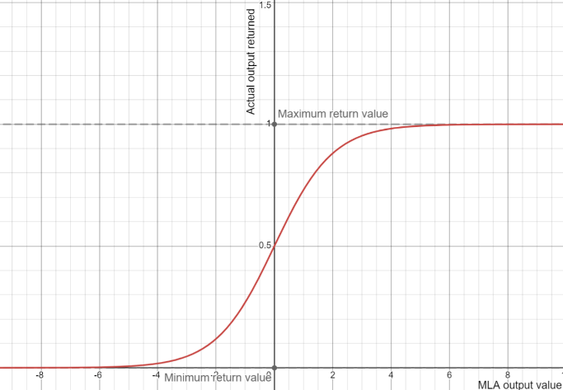

*Figure 1 – Graph showing the MLA calculated output value compared to the actually returned output*

During my research, I had applied an MLA into my physics simulation, however while researching the decision function, which turns an input into an output, in I had misconstructed it several times. The function (where is the final decision and is the MLA output) is supposed to move the cart left with a negative input, and the cart right on a positive input. The MLA I had designed uses a ReLu function (also called a sigmoid function, ) to return , which can only return a positive number between 0 and 1 (*figure* 1) meaning the cart can only move right. The function I used was , meaning that returns different speeds instead of just for the speed limits. However, since , the desicion range is . The second iteration had the function , meaning it had an decision range of , which means the cart can only ever move at half of its maximum speed. I solved this problem by changing the decision function a third time to (*figure 2*), which means that it has a decision range of . When the ReLu and decision functions are graphed as we get the graph found in figure 3, which shows the final speed curve of the MLA output. We graph only because the MLA cannot return values beyond this value. Changing and iterating through these different functions was a good decision as they helped me understand how the algorithms work more thoroughly. By making these changes, the MLA can actually move left and right correctly in order to balance the pendulum.

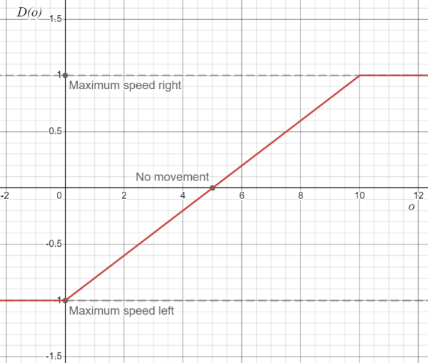

*Figure 2 – Graph showing the decision function of the final MLA*

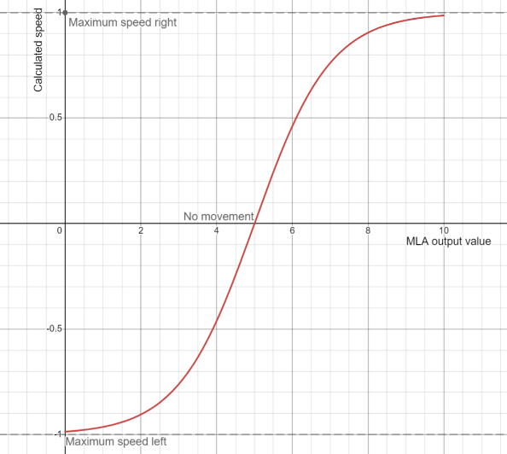

*Figure 3 – Graph showing the calculated speed from actual MLA output that the code returns*

Challenge: Finding someone to interview

E3 Evaluation of the quality of the research Outcome (500 words)